**Final Report**

Data Transmission, Lab 4

Configuring Basic Aspects of MPLS

Authors:

Katwikirize Emmanuel

Yusupov Yuldashbek

3A. Address Assignment

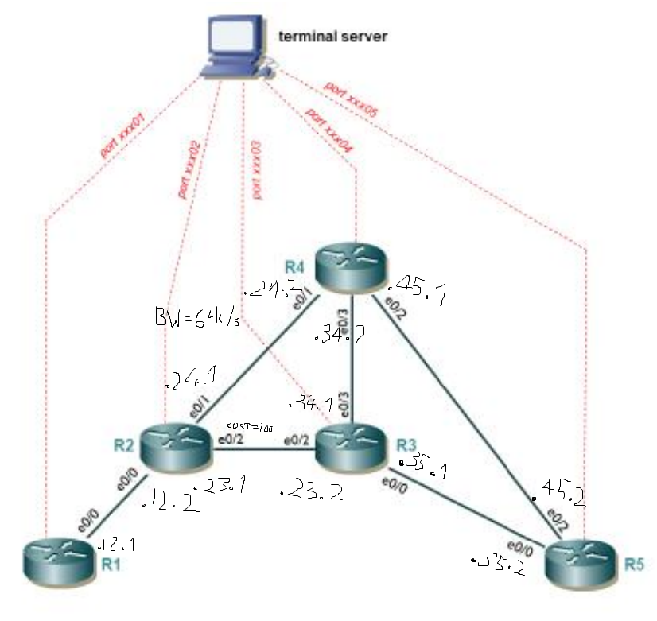

|  |  |
| --- | --- |
| Subnet | Subnet address |
| R1-R2 | 10.0.12.0/30 |
| R2-R4 | 10.0.24.0/30 |
| R3-R4 | 10.0.34.0/30 |
| R3-R5 | 10.0.35.0/30 |
| R4-R5 | 10.0.45.0/30 |
| R2-R3 | 10.0.23.0/30 |
| Router | Loopback Address |
| R1 | 1.1.1.1/32 |
| R2 | 2.2.2.2/32 |
| R3 | 3.3.3.3/32 |
| R4 | 4.4.4.4/32 |
| R5 | 5.5.5.5/32 |

At this stage, we allocated the IP addresses according to the picture above. We assigned each interface on each router a unique IP address and configured the loopback addresses as required.

We then checked that each neighbor relation was set correctly using cdp command:

R1)

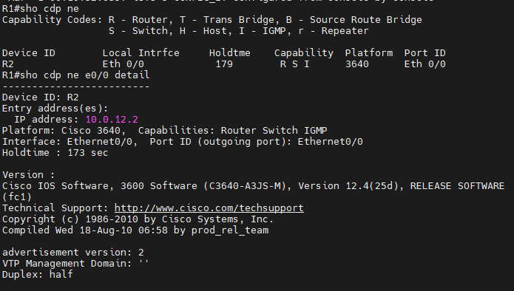

R2)

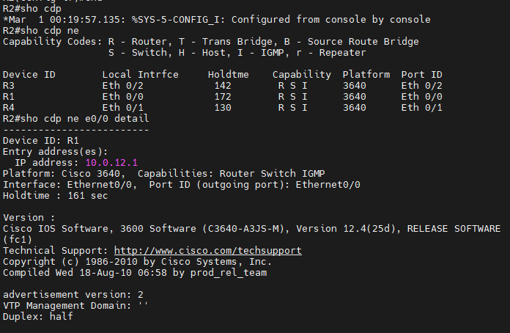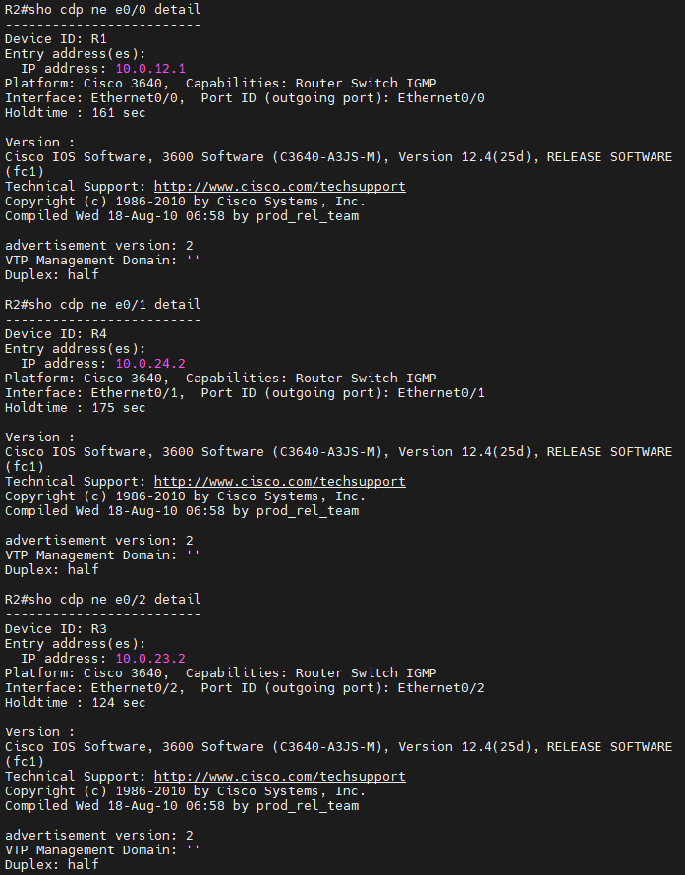

R3)

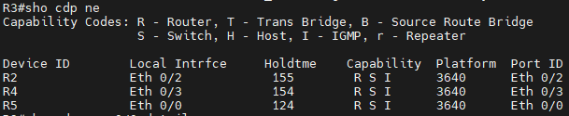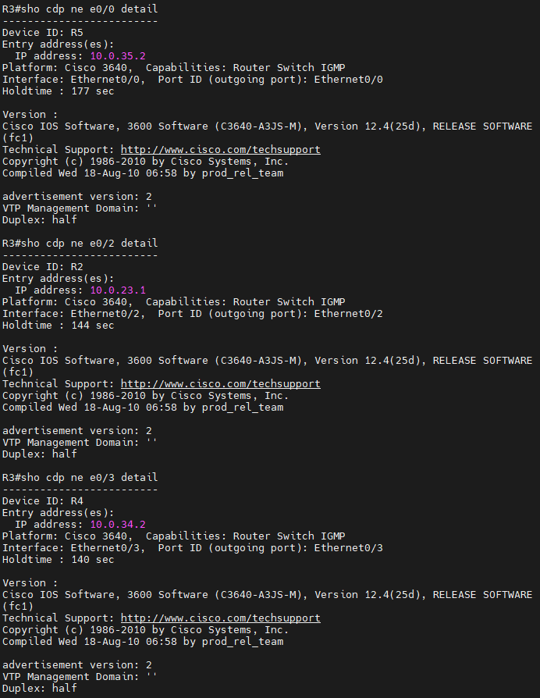

R4)

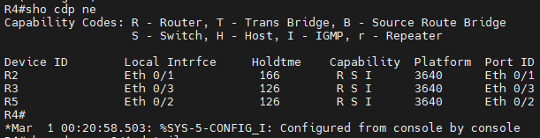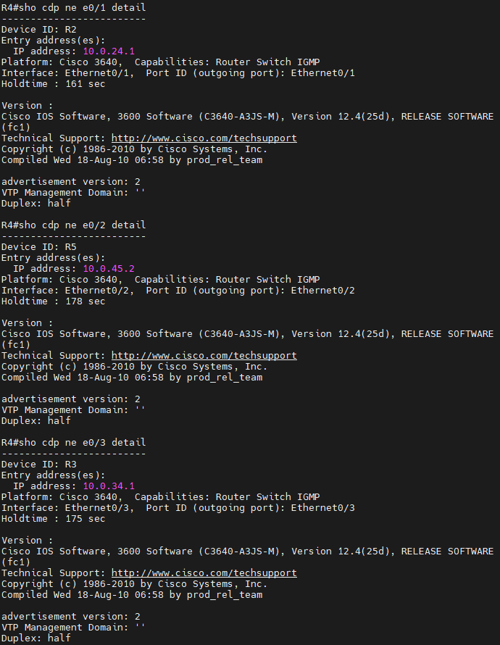

R5)

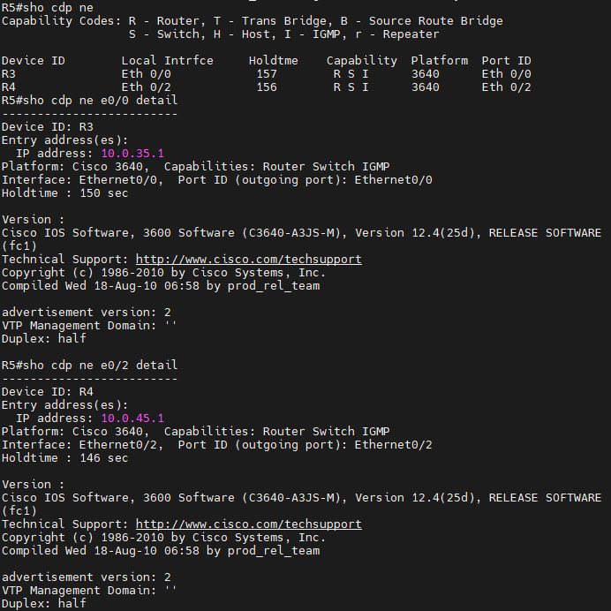

3B. Running OSPF

We then set up OSPF on each interface of each router including loopbacks and made them point-to-point. We also set the cost of the link between R2 and R3 to a 100.

We then checked that the OSPF was set up properly and that all the costs were as expected.

NB: We initially did set this all up correctly, however, we forgot to trace the route between R1 and R5. We set the network up again up to this point in a separate session to check the traceroute, this is why we have two sets of terminal dumps.

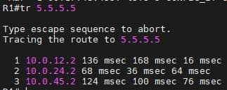

We can see that the packets takes the path R1 -> R2 -> R4 -> R5 avoiding the link R2-R3, because it has a higher cost.

3C. Basic MPLS Configuration

We used the “show ip cef” command to confirm that cef is indeed enabled by default, so that we did not need to enable it. Then we ran “mpls ip” in global config mode on all the routers and on each interface.

3D. Verify MPLS/LDP SETUP

MPLS Interfaces:   
We checked that MPLS interfaces are operational.

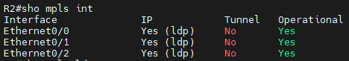

MPLS LDP Neighbors:   
We checked that the LDP neighbors were configured correctly, this command has several fields which we will briefly explain.

Peer LDP Identifier – Shows the LDP identifier of the neighbor, in this case the loopback addresses are being used.  
Local LDP Identifier – Shows the LDP identifier of the router on the neighbor.  
TCP Connection – The TCP connection that supports each LDP session with R2’s neighbors. It shows the neighbors’ and local’s IP addresses and ports used.  
State – Shows that the LDP session is operational.  
Msgs sent/rcvd – Shows the number of messages sent and received on each LDP link. The necessary keep-alive messages are included.   
Up time – Total time the link has been up.  
LDP Discovery Sources – The method in which this LDP session was discovered, in this case it is the adjacent interfaces and their IP addresses.   
Addresses bound to this peer – Shows which interface addresses each neighbor knows.

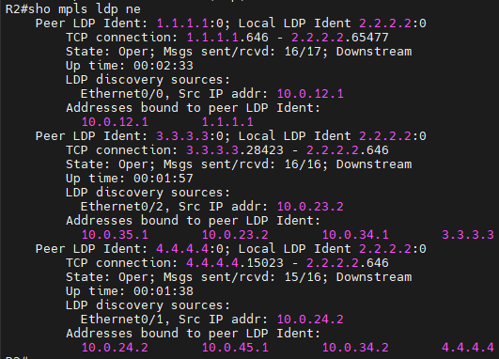

MPLS Forwarding Table:

We can see here the local tags (corresponding to MPLS labels) assigned by R2 and the outgoing ones which represent each label on the next hop. The Prefix or Tunnel ID shows the address/tunnel for each label. Bytes tag switched is the amount of traffic switched through this router with each label. Outgoing interface is the interface used for this label. Next Hop is the IP of the neighbor.

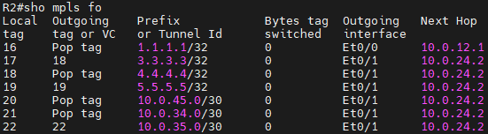

MPLS LDP Bindings:

We have tib entry, which is the IP and mask of the destination. Rev is a number that is used by the router to manage label distribution. Local binding is the label for the prefix. Remote binding is the outgoing label for the destination.

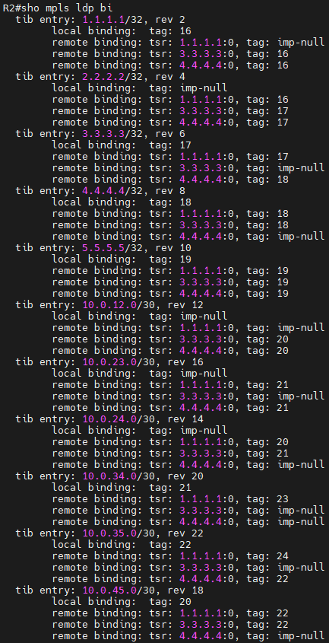

MPLS Forwarding Table Details:

This is the same MPLS forwarding table with additional details. It includes MAC/Encaps which describes the lengths of the Layer 2 header and packet encapsulation.

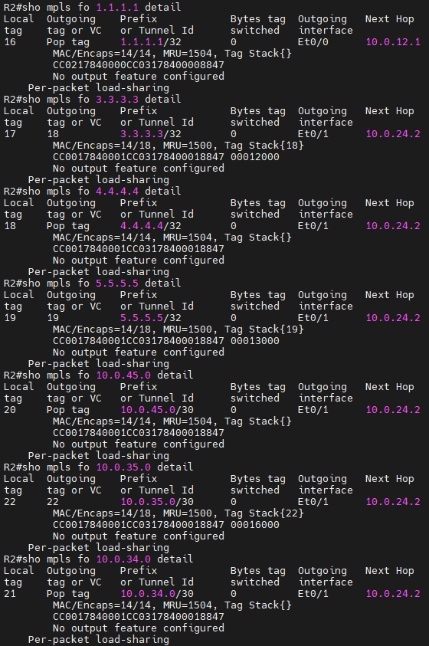

3E. Check Paths

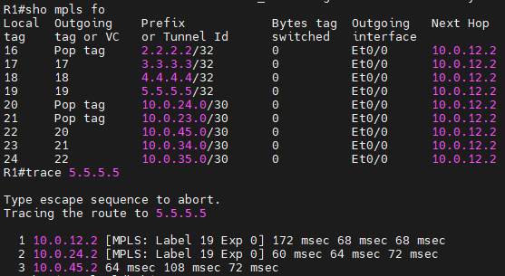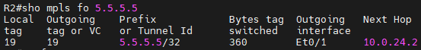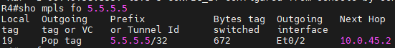

We checked the MPLS forwarding table on R1 to find that the label/tag used for the loopback on R5 is 19, and the next hop is of course e0/0 on R2.  
We also checked the table on R2 to confirm that the label remains the same and the next hop is e0/1 on R4. Then we checked the table on R4 to see that although the local tag is still the same, the next hop is indeed the destination, so the outgoing tag is “popped”.

We then traced the route of our packet from R1 to R5. We see that it takes the expected path, as all hops/interfaces are the same as in the tables. We can also note that MPLS is not used on the final hop.

3F. Configure Basic Traffic Engineering

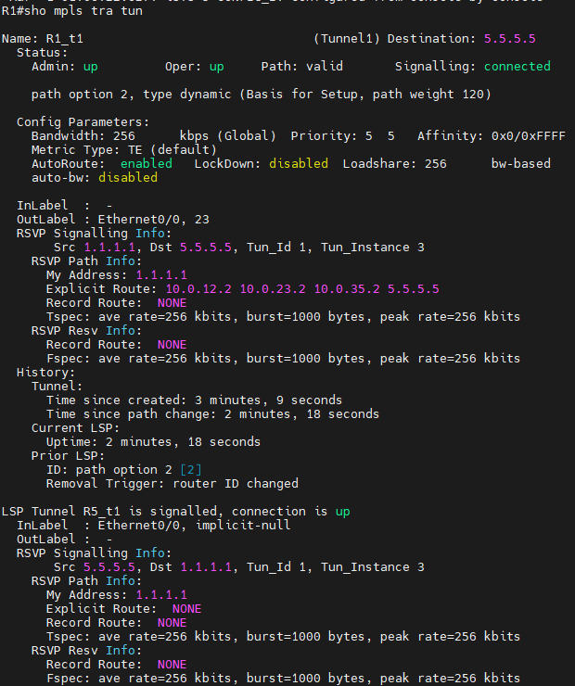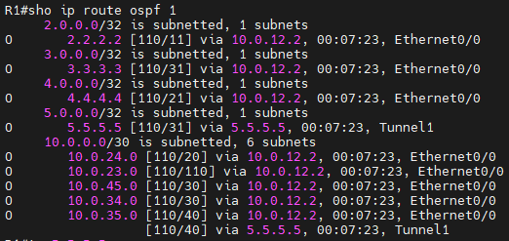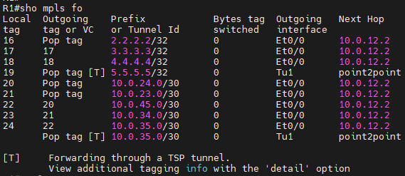

We can see from the output of the “show mpls traffic-eng tunnels” command that the explicit route of this tunnel is R1 – R2 – R3 – R5, which is indeed different from the route in 3E.   
We then confirm that the packets which are destined for R5’s loopback address are taking the Tunnel 1 interface (based on the OSPF table). We can also see that the MPLS forwarding table also pops tags with this destination, and sends them through the Tunnel 1 interface.

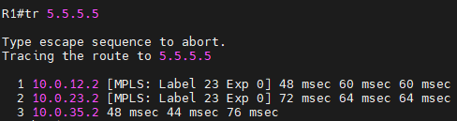

After running traceroute command on R1 we verified that the packet used the expected route.

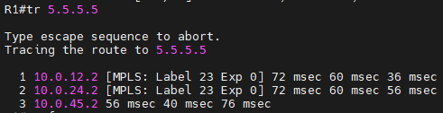

After restoring the bandwidth limit on every router and shutting down tunnel 1, we created explicit MPLS path on tunnel 2 (R1 – R2 – R3 – R4 – R5).  
After running traceroute command on R1 we can see that the packet is now using tunnel 2 with explicit path.